Nama : MIftakhuddin Falaki

Npm : 201843501551

Kelas : R5W

Praktik Encapsulation (Modul halaman 24)

* Class Car

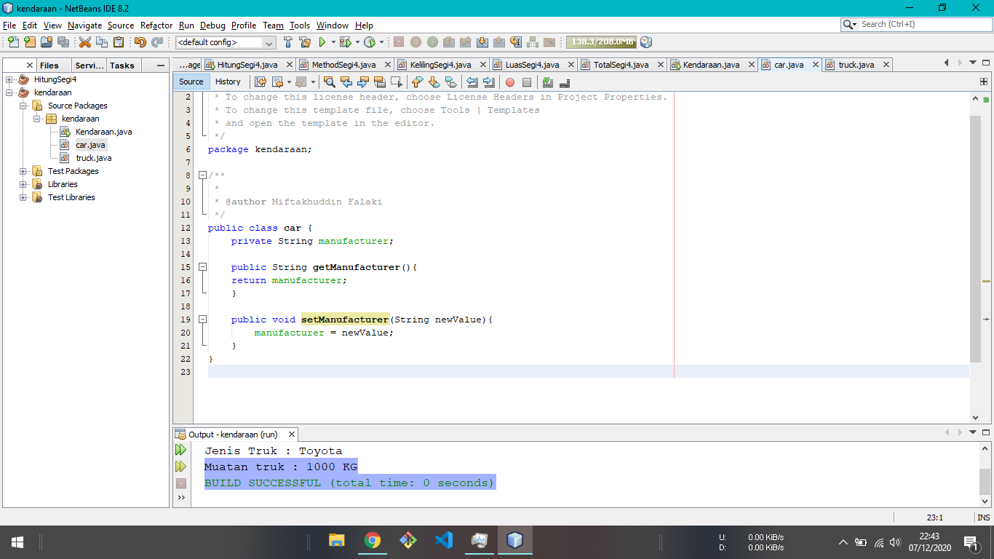

* Class Truck

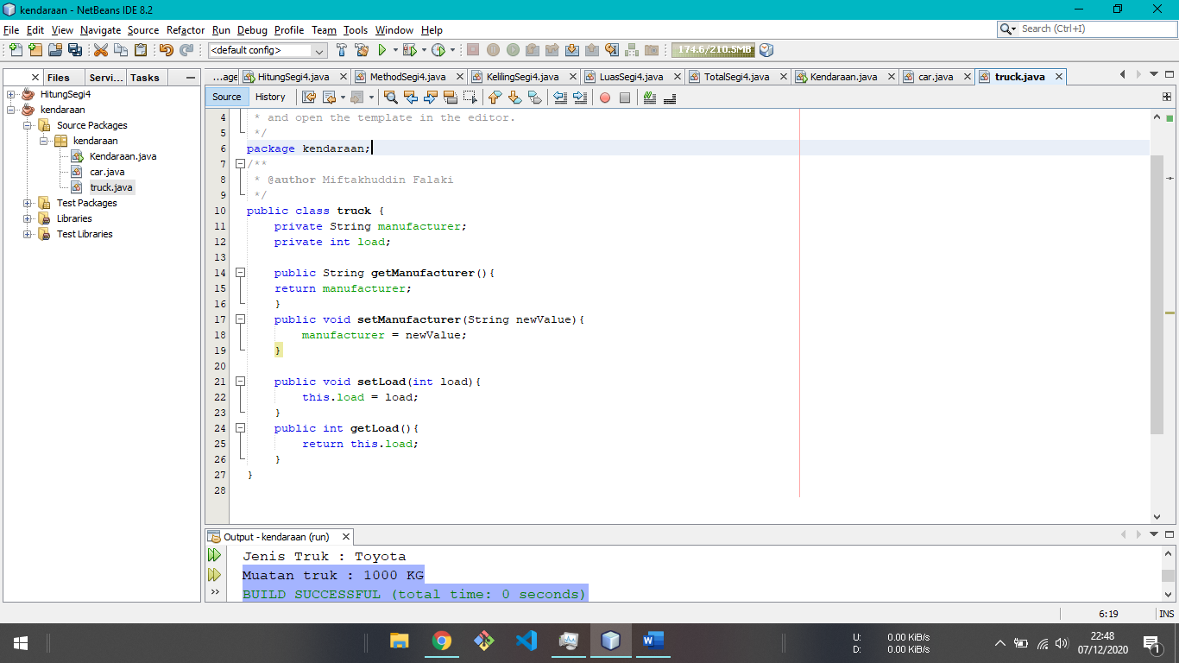

* Class kendaraan ( Main Class )

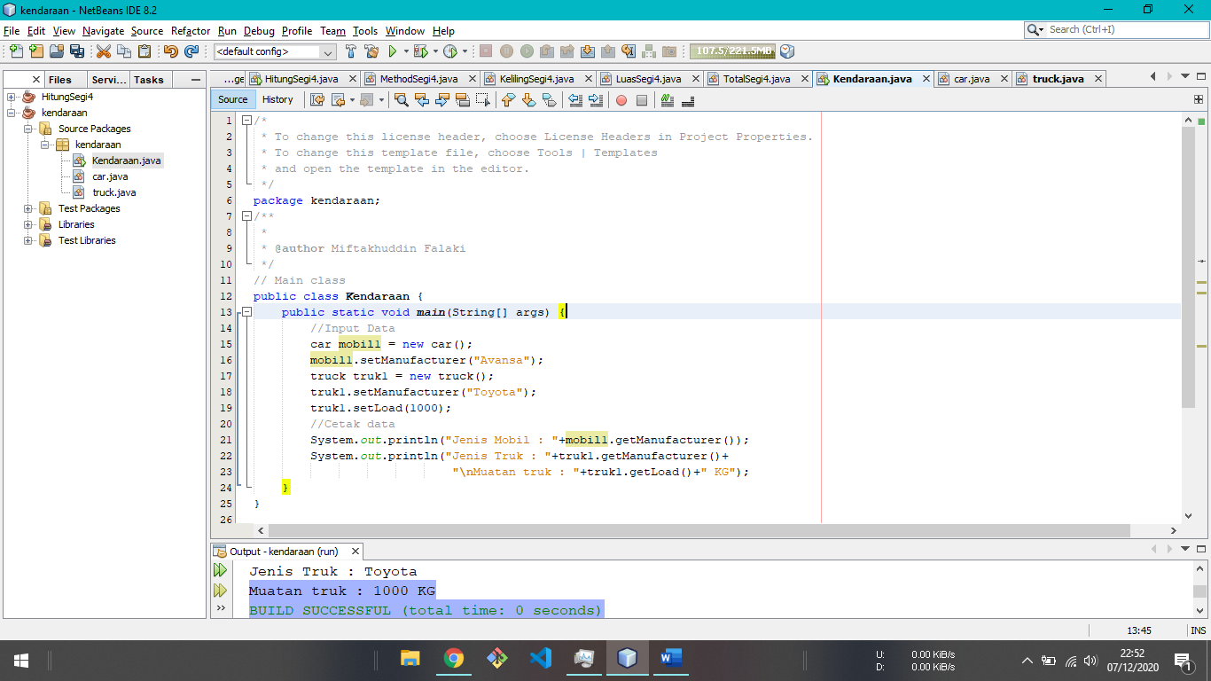

* Output

